

**HCI assignment2: Florence Nightingale Hospice Charity**

Prepared By: Okhueleigbe Aigbe  
Student NO: 1806456  
Module Tutor: Tuan Nguyen

# Application Requirement Analysis

## General Purpose of the Application:

This prototype aims to add, view, edit and delete data related to volunteers by Florence Nightingale Hospice Charity. The users of this interface can enter volunteers’ information, manage volunteering roles and also able to assign various volunteering jobs in order to manage the charity daily activities effectively.

## Functional Requirements:

1. The application must be able to manage all volunteers’ information, their skills, experience and volunteering history.
2. Manage all volunteering roles’ information such as date, time, place and their requirements.
3. The system must be able to keep track of the training volunteers have received.
4. It should be flexible enough to assign a volunteering job to suitable volunteers.
5. The application should be able to generate a report that list volunteers who had reach the 5 years, 10 years or 20 years landmarks.
6. Mangers can find/search volunteers at a specific location and place.

## Non-functional Requirements:

1. Input/output: This is communication method between the user and the graphical user interface prototype.
2. Processing: A requirement for the machine to process the input/output data entered by the user and the interface.
3. User and Human Factors: this requirement involves an interaction between the user and the prototype.
4. Performance: This requirement indicates to how well the prototype is functioning.

# User Analysis

The application is being designed to meet client requirements so it will be very important to know and understand the users of this interface. Highlighting and analysing the user of the interface will allows us to build an application that is user friendly and can also improve the general performance of the charity activities on a day to day basis.

## User Group:

The users of this prototype application are the staff member of Florence Nightingale Hospice Charity that are responsible for recruiting volunteers, responsible for carrying out background checks on volunteers, staff members that send communication to volunteers and also staff members that are responsible for fund raising and event’s organisers.

## User Characteristics:

The interface is designed to accommodate the users' needs to view, add, edit and delete volunteers’ information, the users of the system will need to have possess certain characteristics which will give them the ability to use the prototype application efficiently:

1. Age: users of the prototype must be an adult and because the client is a charity this is an essential requirement.
2. Experience: It is important for the user group to have the adequate amount of experience basic computer skills.

## Interaction style:

The interaction style used between the user and the computer is a Form Fill-in style. The system displays free slots for the user to fill in with the required input data, and then the system performs the task. The required input data and information are specified for the user and are in different form format like volunteer information, volunteering jobs information and form to assign jobs information. Frequently, the system processes the data inputted and performs the necessary tasks according to the commands in the event handler.

# Task Analysis

This stage describes the tasks and methods that will be done by user of the prototype application with the aim of understanding and allocating the various tasks performed by the users. The task analysis is done using the HTA method (Hierarchy Task Analysis) that determines the main tasks along with their sub tasks (if there are any).

## HTA of the GUI:

1. Managing Florence Nightingale Hospice Charity
2. Managing Volunteers’ information. (It is assumed that Volunteer ID will be automatically generated by the system)
   1. Add new volunteer information
      1. Add Volunteer Name
      2. Add Volunteer Address
      3. Add Volunteer Telephone number
      4. Add Volunteer Email
      5. Add Volunteer Experience
      6. Add Volunteer Training
      7. Tick Background Check if Required
      8. Assign Role to Volunteer
      9. Submit new Volunteer information
   2. Edit existing Volunteer information
      1. Edit Volunteer Name
      2. Edit Volunteer Address
      3. Edit Volunteer Telephone number
      4. Edit Volunteer Email
      5. Edit Volunteer Experience
      6. Add Volunteer Training
      7. Tick Background Check if Required
      8. Assign more Role to Volunteer
      9. Submit edited Volunteer information
   3. Delete Volunteer from list of Volunteers’
      1. Select row from the list of Volunteers
      2. Delete the row
      3. Confirm deletion
      4. Row Deleted
   4. View the list of Volunteers
      1. Press "View list"
      2. View List display
3. Managing Volunteering Roles information
   1. Add new volunteering role information
      1. Add role ID
      2. Add role Date
      3. Add role Time
      4. Add role Location
      5. Add role requirements
      6. Submit new role information
   2. Edit existing volunteering roles information
      1. Update/Change role Date
      2. Update/Change role Time
      3. Update/Change role Location
      4. Update/Change role requirements
      5. Submit updated role information
   3. Delete volunteering role from list of roles
      1. Select row from the list
      2. Delete the row
      3. Confirm Delete
      4. Row Deleted
   4. View the list of available Roles
      1. Press "View list"
      2. Select available roles
      3. List display
4. Keep track volunteer training
   1. Add new training of Volunteer
      1. Retrieve Volunteer ID from Volunteers list
      2. Retrieve Volunteering role ID from Volunteering roles list
      3. Add training ID
      4. Add training start date
      5. Add training end date
      6. Submit new training information
5. Assign Volunteering job to Volunteer
   1. Assigning Volunteering Job
      1. Retrieve Volunteer ID from Volunteers list
      2. Check if Volunteer ID has completed training relating to role.
      3. Assign role
      4. Update Volunteer information
      5. Update Role information
      6. Create Role start date
      7. Create Role end date
      8. Submit information
6. Exit system
   1. Press "Exit"
   2. Confirm Exit
   3. System down

The above HTA method is a task outline in text, the task analysis shows all of the main tasks of the GUI in addition to the necessary subtasks for each main task and subtask. In addition, this HTA breakdown allows the prototype developer to know the main functions and tasks of the prototype that will be useful in the design stage.

**Human-Computer interaction dialogue**

One of the most important process is the Human Computer Interaction dialogue. The diagram below specifies the process of assigning a volunteering job to suitable volunteers. This operation allows the user to assign volunteering role from the GUI system according to STN (State Transition Network) diagram that represents the transitions between the states of the task.

## STN Diagram:

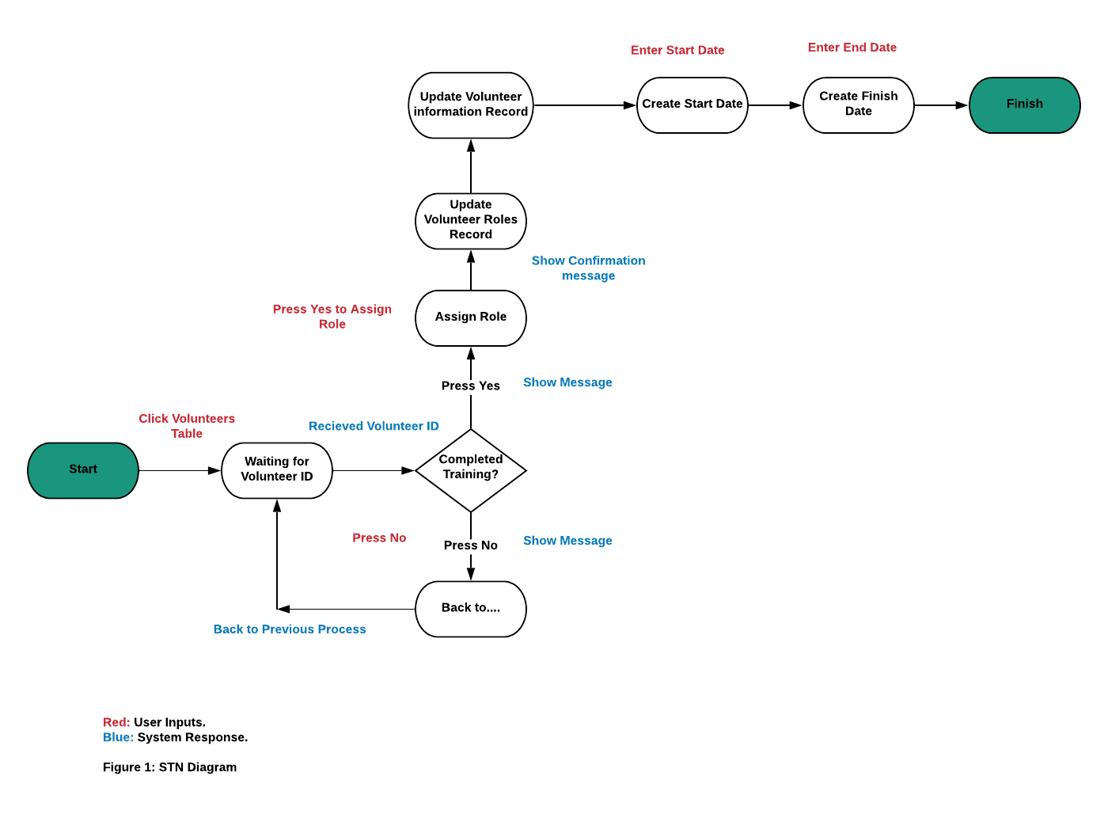

Figure 1 is an STN diagram that shows the necessary steps taken by the user and the system when assigning a volunteering job to suitable volunteers.

# Design User Interface

Figure 2 is the landing form of the prototype application. It has three buttons that will generate an events that leads to it various functional activities, a very warm message to staff of the charity, the charity logo and contacts of the main arms of Florence Nightingale Hospice Charity for easy access.A screenshot of a social media post

Figure 2 is the landing form of the prototype application. It has three buttons that will generate an events that leads to it various functional activities, a very warm message to staff of the charity, the charity logo and contacts of the main arms of Florence Nightingale Hospice Charity for easy access.

# User Interface Prototype

The user interface prototype is the executable program that the user uses as an interaction between the user and the computer. The following screenshots are displays of the prototype interface and a brief description of the tasks and operations is written below each screenshot.

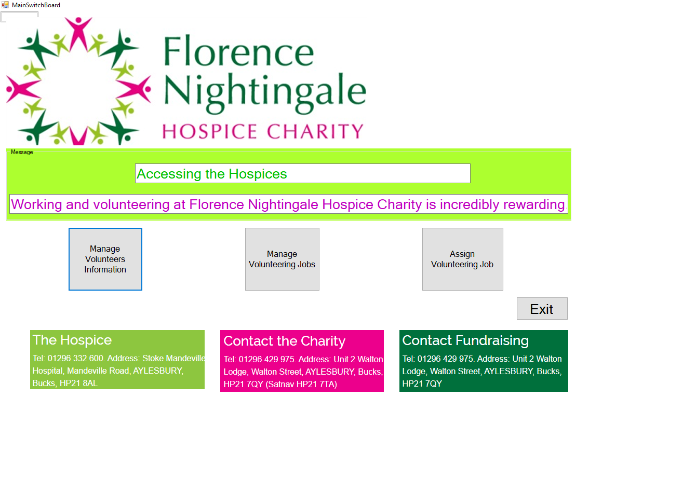

Tab above displays the entry point of Prototype Application. It contains some features of the functional requirements. A click on each button will take the user of the application to relevant forms. The EXIT button will exit the application completely.

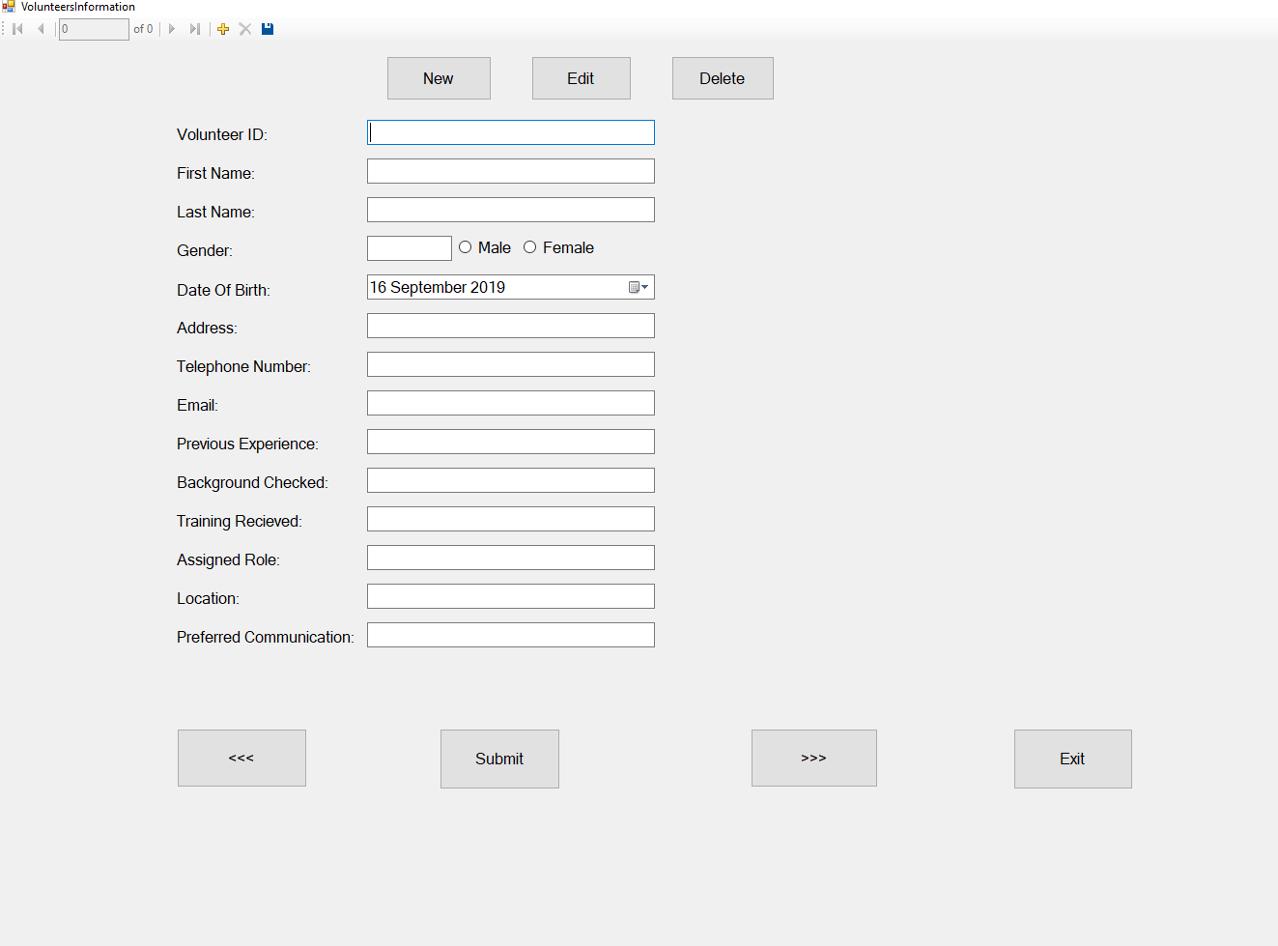

**Tab: Managing Volunteers Information**

Tab above displays the managing volunteers requirements it contain Volunteer ID, First Name, last name, gender, date of birth, address, telephone number, email, previous experience, background checked, training received, assigned role, location and preferred communication.

Some of the function that can carried out are add New, Edit, Delete, submit, previous, next and Exit Form.

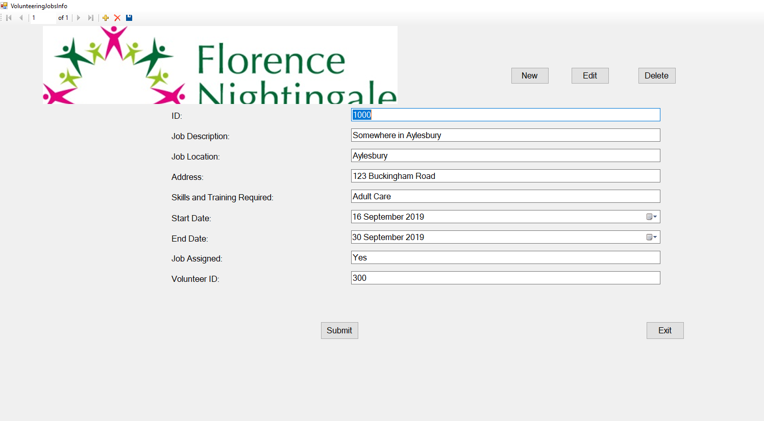

**Tab: Managing Volunteering Jobs**

Tab above displays the managing volunteers requirements it contain Volunteer ID, First Name, last name, gender, date of birth, address, telephone number, email, previous experience, background checked, training received, assigned role, location and preferred communication.

Some of the function that can carried out are add New, Edit, Delete, submit, previous, next and Exit Form.

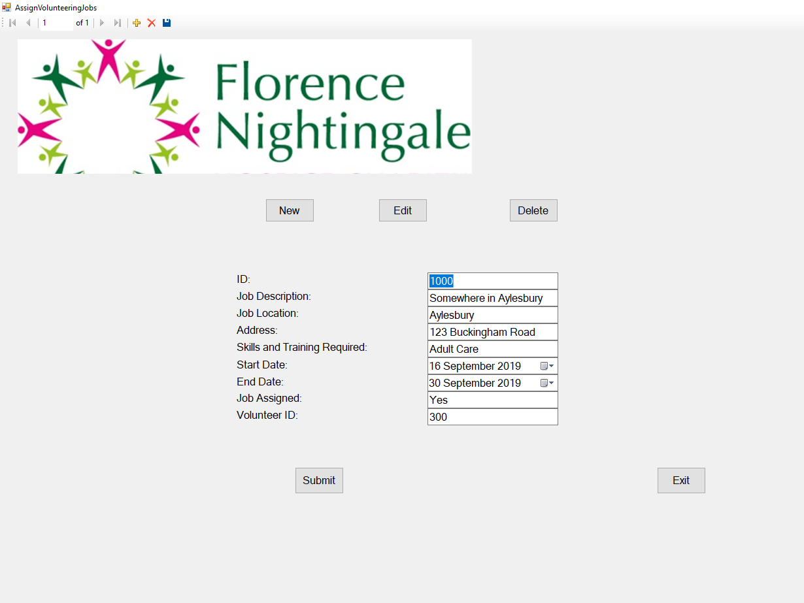

**Tab: Assigning Volunteering Role**

Tab above displays the assigning volunteering role requirements it contain Job ID, Job Description, Job Location, address, Skills and training required, Start date, end date, job assigned and volunteer ID.

Some of the function that can carried out are add New, Edit, Delete, submit, previous, next and Exit Form.

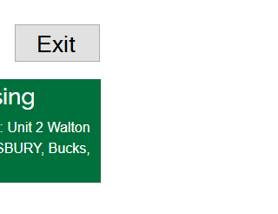

Figure 2 shows the "Exit" button which allows the user to exit the system after pressing it. When the "Exit" button is pressed, a confirmation message box pops up stating if the user wants to exit the system or not, if the user presses "Yes" the system is executed and the prototype is closed. However, If the user presses "No" nothing happens to the system.

Microsoft access was used as a database to manage the forms and this is simple and cheap way for any organisation to manage their data storage.

# Usability aspect of the prototype

**Evaluation and conclusion**

Although the prototype design is really simple it does cover all the needs for an organisation to complete the task from adding new information for the volunteer of the charity. The design can be and functionality can be improved so that more test of functionality can be carried out. The application users that I have mentioned above as it is really simple for them and quick to find information and enter information. This is for experienced user that can enter data quickly. Although my interface can be used by anyone I still made sure that the experienced users are first.

While doing the design I have made sure that the colour and contrast and images used is that of the charity would not be used outside this project or assignment. The effects to the eye has also been taken into account and that labels and buttons are well spaced to avoid any confusion within the navigation for the user. This will avoid any mistakes when clicking on a button or entering information in the right textbox.

I have mock-up was use to draw the initial design and some features was added during implementation of the design.

I am really satisfied with my work and the interface that I have created but due to limited time and other modules competing for time, some features were not implemented.